Bilal Fazili 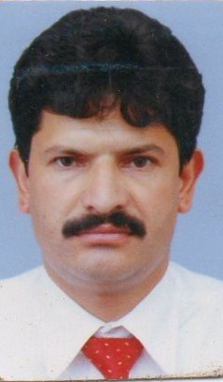 Set No 29-B Govt ResidentialQuarters
Bud-Shah Flats Hari Singh High Street
Srinagar Kashmir - 190001
D.O.B.: 25/03/1980 Mobile: +919419024591 Email:-bilal.fazili@yahoo.co.in Whatt's App +919906798685
Dy. Regional Manager
Pharmaceutical Sales & Business Development
With 14 Years & 09 Months of qualitative experience in:
- Business Development -Sales/Marketing
- Channel Management - Team Management

- Presently associated with DR Johns Lab Healthcare Div Pharmaceuticals Ltd . whole Kashmir.
- A strategic thinker with a flair for charting out strategies for sales and channel management and contributing towards enhancing business volumes& growth and achieving the objective of organization.
- Possess excellent interpersonal, analytical, troubleshooting & team building skill with proven ability in establishing quality systems / procedures and planning /managing resources.

AREAS OF EXPOSURE:-
Business Development / Sales/Marketing
- Identifying and networking with prospective client; generating business from existing accounts and achieving profitability and increased sales growth.
- Analyzing marketing trends and tracking competitor’s achieving and providing valuable inputs for products enhancement and fine tuning sales & marketing strategies.
Channel Management
- Establishing strategies alliances / tie-ups with financially strong and reliable channel partners, resulting in deeper market penetration and reach.
- Monitoring sales and marketing activities, implanting effective strategies to maximize sales and accomplish revenue and collection targets.
- Providing assistance to channel partners by conducting training programs; ensuring seamless delivering of quality products & services in the market.
Team Management
- Recruiting, training and monitoring the performance of team members to ensure efficiency in sales operation and meeting of individuals and group targets.
- Conducting meeting for setting up sales objectives and designing or streamlining processes to ensure smooth functioning of sales operation.

CARRIER:-
- From April 2016 working as DR Johns Healthcare Pharmaceuticals Pvt. Ltd
From October 2012 to March 2016 Worked as ASM in Vadivharie Specialty Pvt. Ltd (Stem cell Storage & Treatment)
- From April, 2008 to Sep 2012: Worked as ASM at Centaur Pharmaceuticals Pvt. Ltd
- Area of Expertise
- Orthopedics,Neurology,Dermatology,Cardio Diabetic,Psycharitry, Oncology, Gynaecology,Nephrology,Dental,General Physicians,Endiconology, Surgery,
- Gasteroenterology,Physicians,Opthamology,Peadiatrics,RMPs,Bums Etc

EDUCATIONAL CREDENTIALS:-
- Bsc. from University of Kashmir. in 2001.
- CTC :- 4.85- Lac /Annum
- As per industrial Norm

ADDRESS: -
Set No 8-Block No 8 Reharie Nallah
Govt. Residential Quarters Reharie Jammu
Srinagar Kashmir 1800001

Bilal Fazili
Dy- RBM

DR Johns Healthcare Pharmaceuticals Pvt. Ltd Jammu & Kashmir-190001

Dated: - 02/06/2017

